STAR SCHEMA:

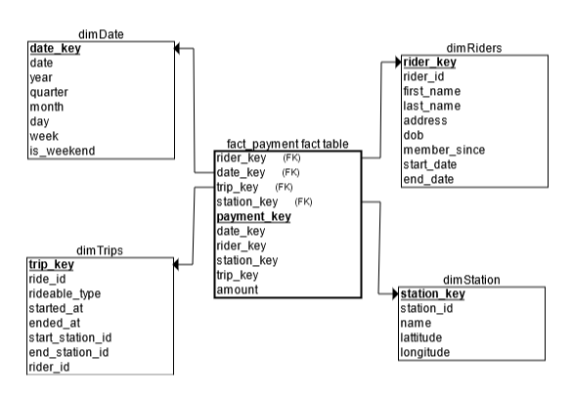

Postgres to Blob

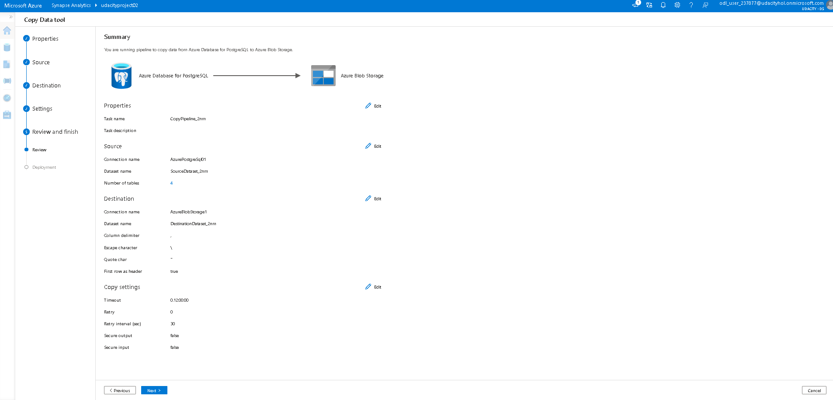

Data: Linked blob files

Resources

